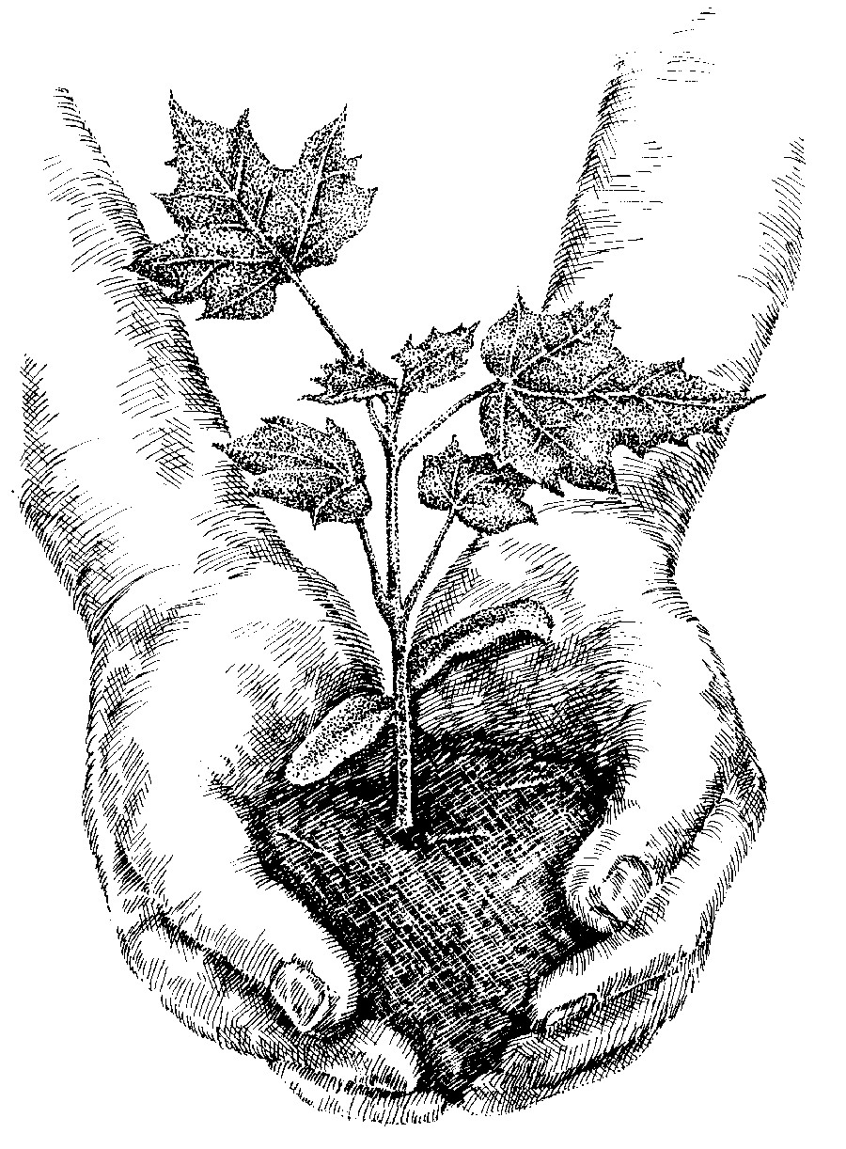
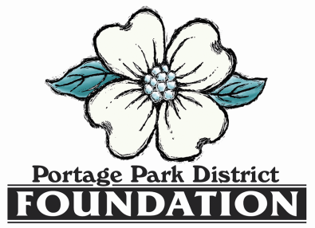

23rd Annual
Environmental Conservation
Awards Event
August 28, 2021

Business or Organization Name (please write it as you want it listed in the program)
_____________________________________________________________________________________
Contact person ________________________________________________________________________
E-mail _____________________________________ Phone ___________________________________
Mailing Address ________________________________________________________________________
SPONSORSHIP OPPORTUNITIES

_____ Eastern Redbud (Up to $99) includes listing in event program.

_____ Eastern White Pine ($100-249) includes listing in event program and on event webpage.

_____ American Beech ($250-499) includes logo and listing in event program, on event webpage,
and on the screens at the event.

_____ White Oak ($500-999) includes logo and listing in event program, on event webpage, on the
screens at the event, on a display poster at the event; and two complimentary event tickets.

_____ Black Walnut ($1,000 – 2,499) includes logo and listing in event program, on event webpage, on
the screens at the event, on a display poster at the event; and four complimentary event
tickets.

_____ Flowering Dogwood ($2,500 and above) includes logo and listing in event program, on event
webpage, on the screens at the event, on a display poster at the event; and eight
complimentary event tickets.

Please submit this form, check and company logo via camera-ready .JPEG file (if applicable)
no later than August 1st to portageparkdistrictfoundation@gmail.com
(EARLY BIRD ADVERTISING OPPORTUNITY: $500 and above sponsorships received by July 7th will be recognized in the 800+ invitations for the event)

Names of all event attendees (tickets in addition to the complimentary event tickets) may be reserved at $35 per person)
________________________________________________________________________________________________________________

Amount enclosed $_____________ (Payable to the Portage Park District Foundation)

Mail to: Portage Park District Foundation, 705 Oakwood St. Suite G-4 Ravenna, Ohio 44266
Event reservations may also be made online at portageparkdistrict.org

