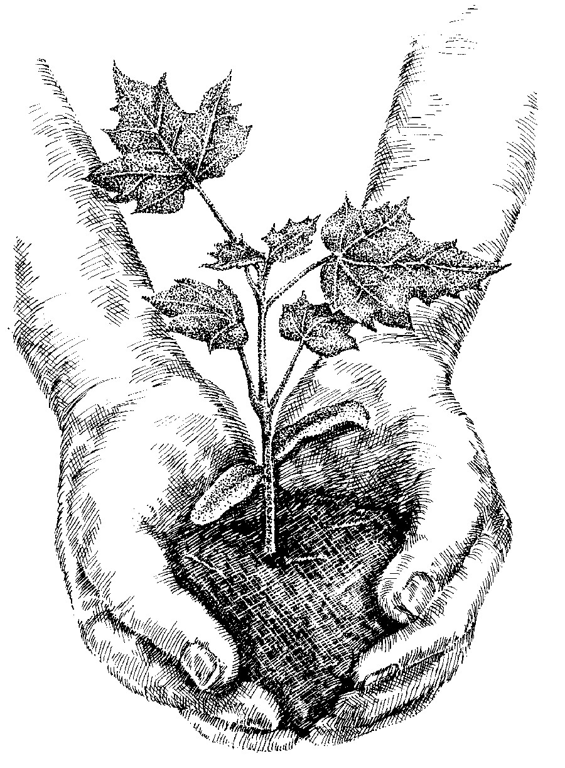
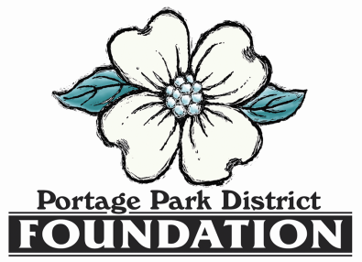

25th Annual
Portage Park District Foundation
Environmental Conservation
Awards Benefit Dinner
April 22, 2023

Business or Organization Name (please write it as you want it listed in the program)
_____________________________________________________________________________________
Contact person ________________________________________________________________________
E-mail _____________________________________ Phone ___________________________________
Mailing Address ________________________________________________________________________

SPONSORSHIP OPPORTUNITIES (due 4/7/2023)
EARLY BIRD ADVERTISING SPECIAL: Logos of $500 and above sponsorships received by March 10th
will be included in the 850+ invitations.

_____ Eastern Redbud (Up to $99) includes listing in dinner program.

_____ Eastern White Pine ($100-249) includes listing in dinner program and on event webpage.

_____ American Beech ($250-499) includes logo and listing in dinner program, on event webpage,
and on the screens at the dinner.

_____ White Oak ($500-999) includes logo and listing in dinner program, on event webpage, on the
screens at the dinner and a display poster at the dinner; and two complimentary dinners.

_____ Black Walnut ($1,000 – 2,499) includes logo and listing in dinner program, on event webpage, on
the screens at the dinner, on a display poster at the dinner and mention by the MC before
and during the dinner program; and four complimentary dinners.

_____ Flowering Dogwood ($2,500 and above) includes logo and listing in dinner program, on event
webpage, on the screens at the dinner, on a display poster at the dinner and mention by the
MC before and during the dinner program; and eight complimentary dinners.

Please submit company logo via camera-ready .JPEG file no later than April 7th (or March 10th to take advantage of Early Bird advertising special) portageparkdistrictfoundation@gmail.com

Names of dinner attendees:______________________________________________________________________________
(tickets in addition to complimentary dinner tickets may be purchased)

Amount enclosed $_____________ (Payable to the Portage Park District Foundation)

Mail to: Portage Park District Foundation, P.O. Box 2327, Streetsboro, OH 44241

